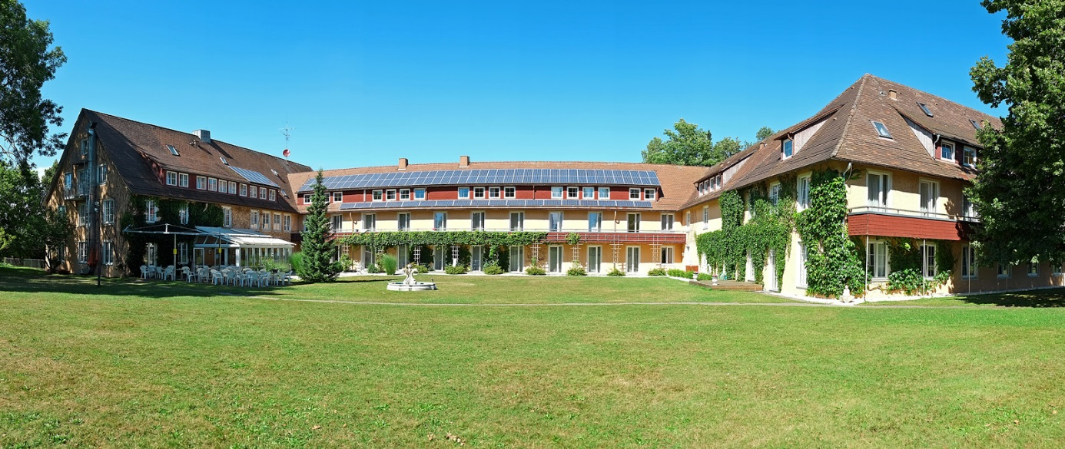
Board and lodging

Seminarzentrum Sonnenstrahl
Sebastian-Kneipp-Str. 1
88353 Kisslegg / Southern Germany
+49 (0) 7563 1890
info@hotel-sonnenstrahl.de
www.seminarzentrum-sonnenstrahl.de

The seminar center is quietly situated and has a wonderful outdoor area with park, as well as thermal bath and a beautiful new sauna area.

Please book your room directly with the seminar center via email:
info@hotel-sonnenstrahl.de

or if you understand German please go to the website:

https://www.seminarzentrum-sonnenstrahl.de/service/zimmerreservierung

After booking your accommodation online, you will receive a confirmation.
Registration by phone only if you do not have access to the internet.
Payment and invoice upon departure after the seminar.

Payment and invoice on departure after the seminar.

Room categories & prices__________________________________

Single room with attached bathroom € 120,00
Double or twin bedroom with attached bathroom € 106,00
Double room with attached bathroom for single use € 130,00
Sonnenstrahlzimmer (large double room) with
attached bathroom € 112,00
Single room with shared bathroom € 95,00
Double or twin bedroom with shared bathroom € 92,00
Dormitory € 85,00
Camping € 71,00

Prices include overnight stay and full board (buffet) per person and refreshment breaks.
The local visitor tax of 1,00 € per night will be charged extra.

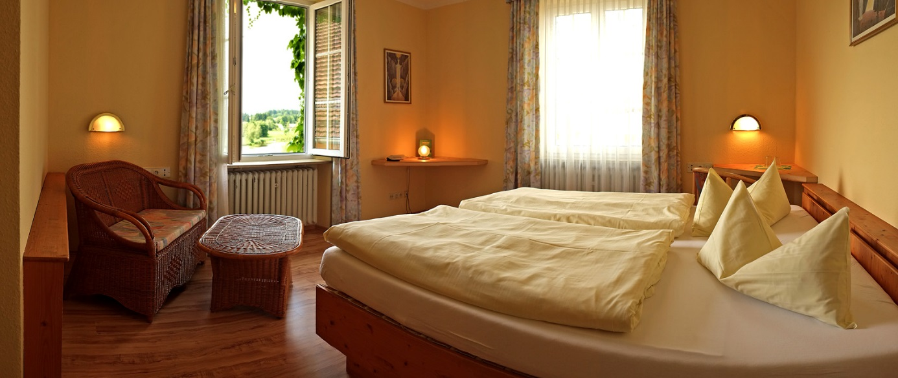

If you do not need accommodation in the seminar centre,
please nevertheless definitely register with the seminar centre to book the conference packages and your meals.

